Grade 5 Science Assessment Task:
Structure & Properties of Matter

Student Worksheet
CCR-Science Standard
SC.5.3.1 Gather, analyze, and communicate evidence of structure and properties of matter.

Task
This task is about states of matter. Read the information below. Then answer the four prompts.
Sam and Alex plan to surprise their grandma with a package of cereal treats. They go to the post office and are told that it costs $10 to mail a box that weighs 4 pounds.
Sam says, “From math class, I know four pounds is equal to about 1800 grams.”
Sam and Alex question if it would weigh less to send just the ingredients or make the cereal bars. Sam and Alex go into the kitchen and begin to weigh the ingredients from the recipe Grandma’s Cereal Bar. The recipe calls for different amounts of marshmallows, butter, and cereal. The recipe for Grandma’s Cereal Bars is shown below.
Grandma’s Cereal Bars
Ingredients
- 4 cups of marshmallows
- 3 tablespoons of butter
- 6 cups of cereal
Instructions
- In a saucepan, melt butter over low heat.
- Add marshmallows and mix completely until the marshmallows are melted.
- Remove the saucepan from the heat.
- Add cereal into the marshmallows until mixed.
- Press marshmallows mixture in a pan.
Sam and Alex measure and weigh each ingredient shown in the picture below.

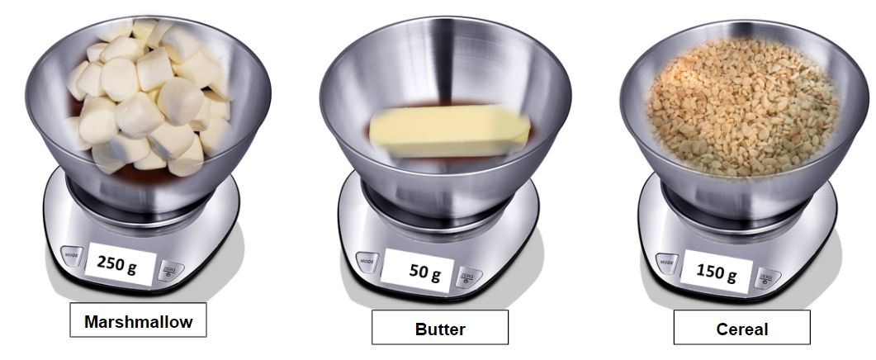
“Kitchen Scale” by xw7229525 is licensed by Pixabay. Marshmallows in a scale weighing 250 grams. Butter in a scale weighing 50 grams. Cereal in a scale weighing 150 grams.

Prompt 1
Use the information from each picture of the ingredients to calculate the total weight in grams of the three ingredients before they are mixed. Show your work in the box below.
What is the total weight in grams of the ingredients before they were mixed? ______________

Prompt 2
Sam and Alex look at the recipe and decide to melt the butter and marshmallows. Then, they weigh each ingredient before mixing them together.
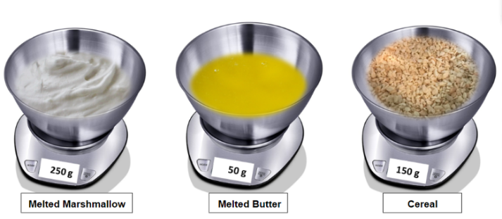
“Buttercream” by jessicashaylerjs is licensed under CC0 1.0 (https://creativecommons.org/publicdomain/zero/1.0/)
Bowl of melted butter with the background erased by Douglas P Perkins is licensed under CC BY-SA (https://creativecommons.org/licenses/by-sa/3.0)
“Kitchen Scale” by xw7229525 is licensed by Pixabay. Melted marshmallows in a scale weighing 250 grams. Melted butter in a scale weighing 50 grams. Cereal in a scale weighing 150 grams.

Sam and Alex create a table, Weight of Cereal Ingredients, to sort their data.
Use the pictures above and data about the ingredients before and after melting to complete the table, Weight of Cereal Bar Ingredients, shown below. Show your work to complete the table in the box, Show Your Work, below.
Show Your Work

Weight of Cereal Bar Ingredients
Weights of Ingredients in Grams | Weight Before Heated (Grams) | Weight After Melted (Grams) | Difference Before and After Heated (Grams)
4 cups of marshmallows
3 tablespoons of butter

Prompt 3
Use the completed table, Weight of Cereal Bar Ingredients, to answer the following questions.
- What is the weight in grams of the melted marshmallows? _________
- What is the difference between the weight of the marshmallows before and after they are heated? ____________
- What is the weight in grams of the melted butter? __________
- What is the difference between the weight of the butter before and after it was heated? ___________
- In the space below, answer the following question. What can Sam and Alex conclude about the weight of ingredients before and after they are heated? Support your answer with evidence from the table.

Prompt 4
Sam and Alex make the recipe for grandma’s cereal bars. They mix all the ingredients together in a pan and let the cereal bars cool. No crumbs were lost! After the cereal bars cool, Sam and Alex weigh the cereal bars.
Part A. What will the final weight in grams of the cereal bars be after they have cooled? Show your work and put the answer on the line in the box.

Final weight of the cereal bars after they have cooled:____________________
Part B. What can Sam and Alex conclude about the weight of ingredients before and after they are mixed? Be sure to include what you know about the properties of matter. Support your answer with evidence from the table and the information above.

