Grade 5 Science Assessment Task:
Structure & Properties of Matter

Student Worksheet
CCR-Science Standard
SC.5.3.1 Gather, analyze, and communicate evidence of structure and properties of matter.

Task
This task is about the structure and properties of matter. Read the information below. Then answer the four prompts.
Bob and Sue want to go to the park on a hot day. Sue wants to bring really cold water to drink. But, she worries that the water would be too heavy to carry if frozen. Bob asks Sue if the water bottle would be heavier if it is frozen solid.
Bob and Sue decide to find out. They weigh three water bottles on a scale. The water bottles each weigh 450 grams. Bob says, “The weight of 1 gram is as much as 1 paperclip. Each bottle weighs as much as 450 paperclips.”
They put the bottles of water in the freezer and remove them when the water is frozen solid. They weigh each of the bottles.

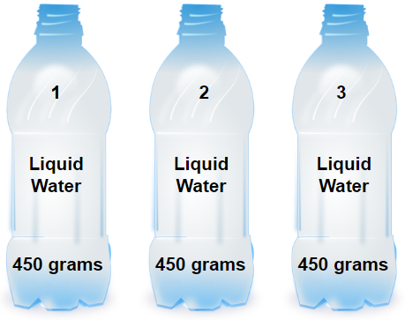 | 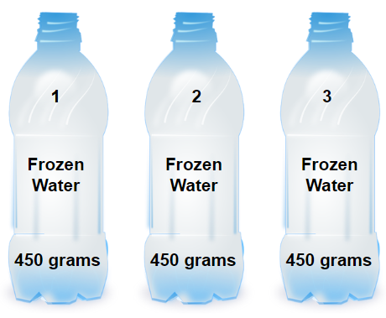
Picture of three liquid (or frozen) water bottles. Each bottle is marked with a weight of 450 grams.
“Pet bottle” is in the public domain.

Prompt 1
Bob and Sue create a table to show the weight when the water is in a liquid form and when the water is in a solid form. Complete the table below, Water Weight Liquid and Solid, using the information in the pictures of the liquid water and solid water.
Water Weight Liquid and Solid
Weight of Water in Grams | Liquid | Solid
Bottle 1 | 450g
Bottle 2 |  | 450g
Bottle 3 | 450g
Average | 450g | 450g

Prompt 2
What did Bob and Sue discover about the weight of water when it is a liquid and a solid? Support your answer using the information presented in the pictures of the bottles of water when they are in a liquid state and a solid state and the Table you completed.

Prompt 3

Bob and Sue have a 1/2 pound of ice cream in the freezer. They take the ice cream out of the freezer and place it on the counter. They want to make ice cream soda floats. Bob and Sue realize that they don’t have any soda. They run to the store to get some. When Bob and Sue return, the ice cream is completely melted. How much does the melted ice cream weigh? Use the evidence from the table, Water Weight Liquid and Solid, to support your answer.

Prompt 4

Bob and Sue place the ½ pound of melted ice cream back in the freezer. They are hungry for the ice cream sodas so they check on the ice cream every 10 minutes for one hour to see if it is frozen. They are curious about what happens to the weight of the ice cream while it is going through the freezing process. They weigh the ice cream each time they check it. Construct a Weight vs Time line graph that would show what is happening to the weight of the ice cream while it is in the freezer for one hour.

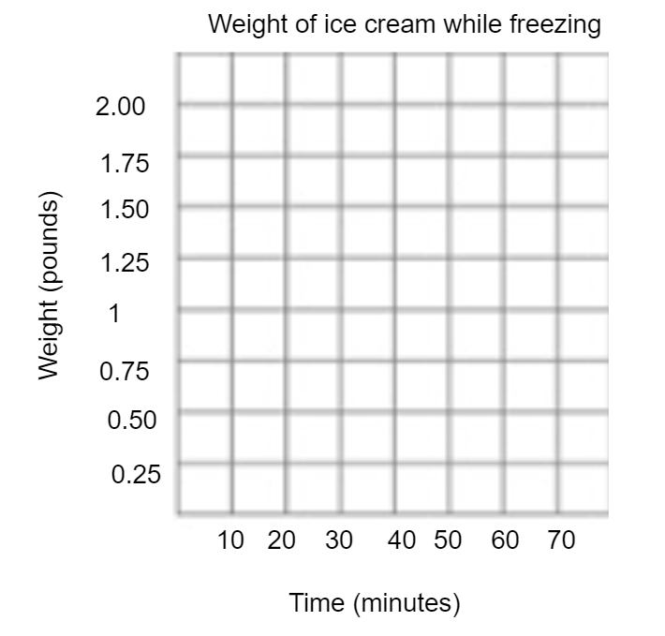

Prompt 5

After constructing the line graph above, describe the line and explain why it looks the way it does. Use evidence from any of the prompts above to support your reasoning.

The shape of the line is __________________________________________________________

The reason it looks like this is

